14 TIMES WINNER OF ANS BEST REGIONAL NEWSLETTER

Southern Navion Air Group
Newsletter JANUARY 2020

FLY-IN REPORT

I believe most folks heard that the Gadsden, AL fly-in, hosted by James Herrington and Nick Kanakis on Oct. 25-27, 2019 was weathered out. Those that drove in managed to have a good time, but 100’ ceilings and rain prevented even the locals from any flying.

SHADE TREE FLY-IN will be held February 28-March 1st, 2020 at MS82. The hotel remains the Hampton Inn & Suites (228) 537-0601 and ask for Jessica or Brianna for the SNAG (25) room block being held through 2/14/2020. Complimentary breakfast is available in the hotel dining area and we’ll have the meeting room.

We’re still working out the details of the meal agenda, but know that we’ll have Friday & Saturday evening food worked out shortly. Saturday morning dawn patrol, lunch at the airport and then games. Saturday evening we will be dining together, then back to the hotel for business, cocktails etc. Since the 2-year business meeting was lost to weather at Gadsden, we’ll be conducting our “official” business meeting and voting in new officers Saturday evening. Regular Sunday departure.

FUTURE FLY-INS

We’re planning to have a Fall fly-in in Covington/Abita Springs, LA. to take advantage of the local activities recently featured in the AOPA flying destinations program, Oct/Nov-exact date TBD. Still finalizing locations for both Memorial Day and Labor Day- options include Birmingham/Bessemer, AL at KEKY, Oxford, MS area, San Antonio and Ron Hanselman’s offered up his place at Bourland Field just SW of Ft. Worth.

We’ll be discussing these at Shade Tree but if you can’t make it and want to provide input, please give Lee Holmes a call or shoot him an email: mleeholmes@sbcglobal.net or cell: 254-780-6038.

Of course, don’t forget the ANS Annual Convention in Spearfish, SD. June 21-27th! Details in the ANS newsletter or website.

ANS PARTS SHOP

Many of you are aware by now that we lost the long-time parts manager for ANS, Chuck Brown to cancer on Nov 21, 2019. Chuck provided knowledge beyond just supplying parts and he’s going to be missed by all who have come to depend on his deep Navion parts experience. Gary Rankin has been holding down the fort admirably the past couple of months and trying to back-fill both customer orders and re-fill inventory. Gary and the Board of Directors have taken the necessary steps to move the entire warehouse inventory to a new location (tentatively Idaho) at an airport that will facilitate Navion owners’ ability to fly in and get their parts. The parts service will be managed by an experienced Navion A&P who should be able to provide some of the “added knowledge” we had come to depend on Chuck for. Gary will be providing details in an upcoming edition of the ANS newsletter.

LATE BREAKING NEWS: We just received word that the McSpaddens have just sold their long-owned, almost 10,000 hour Navion 5318K. Taylor and Andrea Neild in partnership with Mike Oszczakiewicz have moved 18K to Beaumont, TX, so we should continue seeing it in SNAG. Hope the new owners will fly and enjoy it just as much!
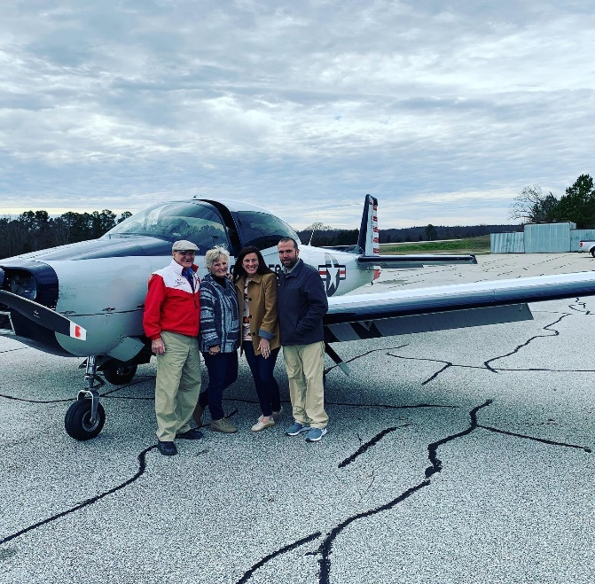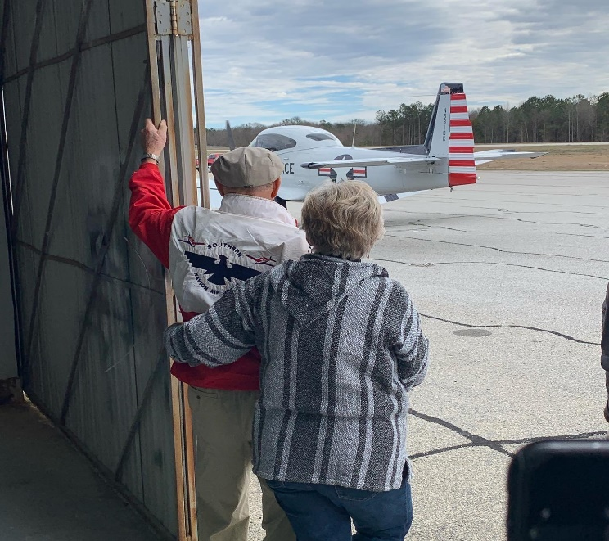

FLY-IN CALENDAR 2020

- Feb 28-Mar 1st: Shade Tree Airport, MS
- March 31 - April 5, 2020: Sun-N-Fun, Lakeland, FL
- May/Memorial Day 2020 – open
- June 21-27, 2020: ANS Annual Convention, Spearfish, SD
- Sept 4-7 Labor Day 2020 – open
- Oct/Nov 2020 – Covington/Abita Springs, LA.

THINKING OF HOSTING A FLY-IN…
On the Facebook page under “files” is a neat checklist from Ann McSpadden with all the instructions anyone needs to host a fly in! What a great was to show off your local airport and part of the US. If you are willing to possibly host a fly-in for the 2020 season, please contact Lee Holmes
mleeholmes@sbcglobal.net or 254-780-6038

SNAG NEWSLETTER/JAN 2020
Susan Holmes
4109 Lucas Lane
Lake Charles, LA 70605

SNAG

