14 TIMES WINNER OF ANS BEST REGIONAL NEWSLETTER

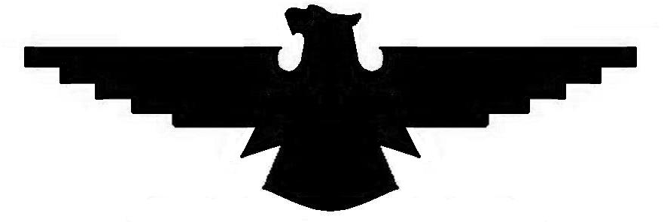

Southern Navion Air Group
Newsletter SEPTEMBER 2025

FROM THE PREZ

The Port St. Joe fly in was a great success. The seafood boil on Friday night and hot dogs and hamburgers on Saturday were super and made everything very convenient. Bud’s hanger faces the runway so everyone had a front row seat for the festivities. Balloons were poped, bombs were dropped, and the spot landing was interesting as always. Sometimes our pilots are great and other times we wonder how they find the runway, (just kidding). The brunch patrol went well. I had the distinct honor of being Tail End Charlie again so I had the best seat in the house.

Looking ahead at all of the NAvions flying along the beach was a treat. Thanks Bud for inviting us.
The 2025 fly in season is almost over with only one fly in remaining which will be at the Concordia Parish Louisiana airport on November 7th , 8th and 9th just across the river from Natchez, MS. Denise Walker will be hosting. Get your reservations in early so you don’t miss out on the fun. Shade Tree fly-in will be in late February or early March 2026 but we still need to firm up fly in’s for the rest of the 2026 season. There are a couple of ideas on the table but we need more, so if anyone is interested, let me know. See ya soon.

Fly safe and fly often and if you fly through my neighborhood stop in and visit.

Paul

Editor’s additions: Joining us at Costen Field A51 were: Dick and Ann McSpadden, Wayne and Ellen Whitaker, Rusty and Wanda Herrington, Lee Holmes, Dave Knesek, Bruce Herrington, Bobby Herrington,
Paul Wright, (host) Bud & Suzi Raymond, Leo Langston, Les White, John Hinkley (DFW area) fixed wing air ambulance pilot looking for his dream Navion, K.C. Shokoui in his 17 hr. Thatcher experimental (his Navion is down for a bad cylinder), and briefly…Dave Morgan. Flying competitions saw fairly low turnout with six competitors. Winners were as follows: Spot landing had Bobby Herrington in 2nd and Bruce Herrington in 1st place; Balloon bust: Bobby Herrington 2nd and Lee Holmes 1st; and Bombing saw Lee Holmes 2nd and Les White 1st . Our sincere thanks to Bud and Suzi Raymond and all their neighbors who made us feel most welcome.

FLY-IN’S:
November 7-9, 2025 Natchez/Vidalia, MS hosted by Kevin and Denise; See detailed attachment
Late Feb/early March 2026, Shade Tree, MS.
June 2026 ANS Annual Convention, Hartford, Wisconsin, KHXF
July 20-26, Navion 80th Anniversary arrival, EAA Airventure, Oshkosh, WI
Other locations being worked include: Bentonville, AR; Vicksburg, MS; Laurel, MS; & Fredericksburg, TX.
Please let us know if you want to host a fly-in at another location and we’ll be happy to help walk you through the hosting process.

SNAG NEWSLETTER / SEPTEMBER - 2025
Lee Holmes
11881 Longfellow Cir
Shreveport, LA. 71106

