14 TIMES WINNER OF ANS BEST REGIONAL NEWSLETTER

Southern Navion Air Group
Newsletter DECEMBER 2022

Words from the President: (FREDERICKSBURG)

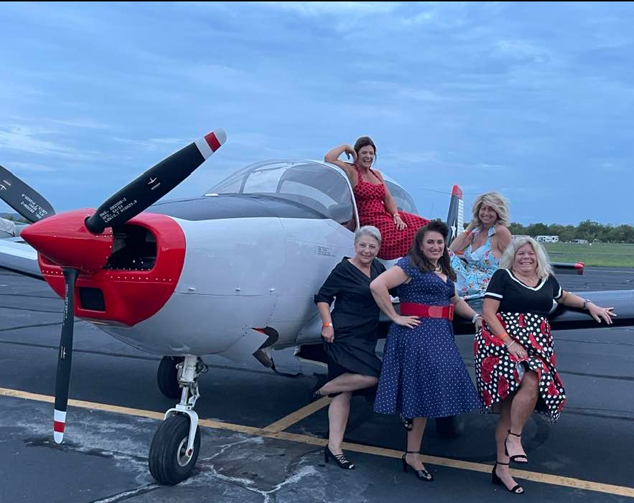 | 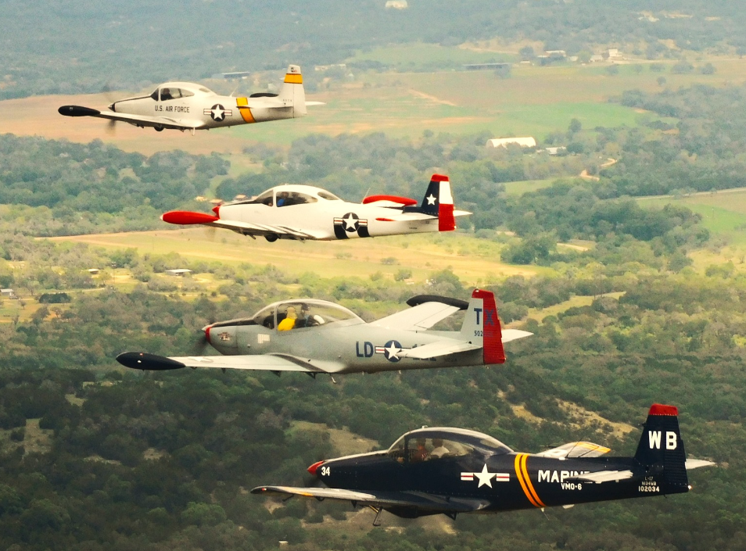

Left: SNAG ladies pose with Kevin’s plane during the ‘40’s USO dance at the Hangar Hotel (L>R Jodi Meaux, Phillis Domingue, Denise Walker, Michele Alleman, Peggy Fisher; Right: Chris Walker-lead, Kevin Domingue-#2, Greg Young-#3, & Chris Meaux-#4, formed up over Central TX, photo courtesy of photo ship flown by Rusty Herrington.

SNAG family, if you did not attend The Fredericksburg fly-in you missed one for the ages. Lucas & Courtney Walker provided an absolute wonderful time. We had a nice, enjoyable, and relaxing time touring the area and everyone seemed to enjoy their weekend. The Hanger Hotel with its amenities and diner next door is easy to relax and take advantage of the intimacy it provides.

We did not host flying activities except for a brief patrol over the area. The weather forecast seemed gloomy at first, but we were able to see 5,500’ ceilings so it never materialized into much concern.

The main event was the USO dance for which some dressed the part, including yours truly. This provided a perfect backdrop to the airport atmosphere of planes, friends, family, and a good time! Here are few more pictures of the crew:

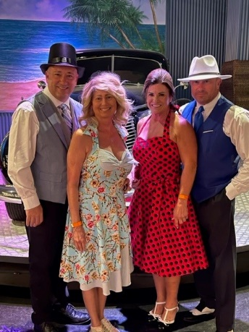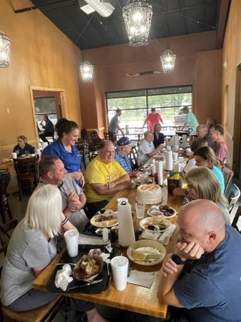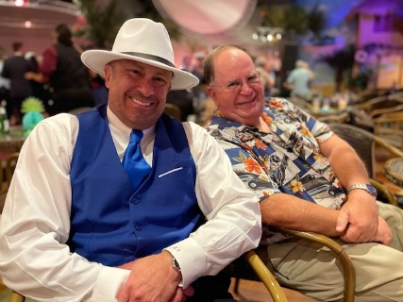

Joining us in Fredericksburg were: Hosts: Lucas & Courtney Walker, Rusty & Wanda Herrington, Chris & Jodi Meaux, Ron & Denise Hanselman, Greg Young, Kevin & Phyllis Domingue w/guests Mike & Michele Alleman, Chris & Denise Walker, Steve & Lita Ware, Chuck & Peggy Fisher, JT & Ora Dell McMahon, Mike & Erica Kading.

I want to thank everyone for taking the time and effort to attend the fly-ins this year and for those that couldn’t make one, we missed you! We had a very successful 2022 and I am looking forward to 2023 and all the fun to come.

I was unable to make the Mt. Pleasant fly-in due to a corporate work engagement in Nashville, TN so I have asked others to provide a few comments on the event.

Mt. Pleasant Fly-in:
SNAG visited the lovely town of Mt. Pleasant, TX over the October 14-16 weekend. Our host Kevin Domingue had to attend a work event where he and Phyllis were recognized by their franchise corporation (Neighborly) as one of the top 5 producing locations in the country and were awarded both the rookie of the year and the Admiral level sales award. But enough about Kevin and Phyllis, let’s talk about us!

Friday evening we enjoyed a great dinner on the patio at Two Senoritas Mexican Restaurant with a relatively early trip to the museum Saturday from 9-noon. The main attraction was the Mid-American Flight Museum where we saw about two dozen of the best refurbished aircraft in the country including an A-26 converted for executive transport, a Spartan Executive, the mandatory C41 and C-47, Stinson & Ford Tri-Motors, Grumman Albatross, and many others in pristine flying condition. A crowd favorite was the now completed Travel Air 4000 which many of us saw in pieces last summer at the ANS Convention when we visited Mid America’s workshop in Urbana, OH.

Based on forecast of severe weather Saturday night and Sunday all day, we had a great lunch and then everyone blasted off for home to avoid getting stranded. Joining us in NE TX were: Joe Doll, Greg Young, Paul Wright, Lee & Susan Holmes, David Bejvan (visiting from MN and the Midwest Chapter), Rusty and Wanda Herrington, Dave Knesek, and Carl Jenkins. (Apologies if I missed anyone.

Navion Story: Mods to N48JR
Lee and Susan Holmes have been flying N48JR, aka “Junior”, for the past two years after purchasing from Larry Austin following an extensive refurb by Cecil Austin around 2012-14. She’s been flying great but we were ready to add some improvements based on some worn components. We converted one mag to the Electro Air electronic ignition system (per STC/AML) and replaced the standard windshield with a super-sloped windshield. BLUF (Air Force speak for “bottom line up front”): This was a time-consuming project at substantial cost but produced excellent performance and looks. The cost of the ignition was $4000 plus roughly $2000 in labor. (That doesn’t include the entire fuel system and exhaust system replacements due to severe problems found during the upgrade work.) The Super-sloped windshield was about $1,600 from ANS and took roughly 4 days of work but produced a beautiful and quiet platform. Special thanks to my sensei, spiritual & sheet metal guide Greg Young for his steady hand in guiding, spoon-feeding and in many cases actually doing the work. Thanks also to Kevin and Phyllis Domingue who housed me and provided a fair amount of hands-on help. After Chris and Denise Walker’s windshield is completed, Greg & Kevin may consider retiring. Both of my projects were done nearly concurrently so I can’t attribute performance increases to one versus the other, but in total I picked up about 6-7 mph while reducing fuel burn by about 1 GPH (ignition upgrade). Based on $6/gal. AvGas, I project break even on fuel savings in 5-6 years, not including savings from not having to inspect/overhaul one magneto every 500 hours, probably another $1,000 saved. Happy to talk to anyone who is considering either of these upgrades about the details of my experience. Thrilled with the results but equally excited to be done with them.

2023 Fly-In’s/SAVE THE DATES:

- Shade Tree, MS. MS82, March 10-12, 2023. Details forthcoming, but expect the normal outstanding hospitality from Danny and Janet Miller
- Memorial Day, May 26-29, 2023: Proposed joint fly-in with the Midwest Navioneers. Currently evaluating locations most logical/central to both organizations in the region of KY/TN/MO/IL intersections.
- Two remaining dates open: Labor Day and Winter (Oct/Nov) We’d love to have you host a fly-in at your favorite flight destination. See “Hosting a Fly-in” below:
WANT TO HOST A FLY-IN?
We have a neat checklist from Ann McSpadden with all the instructions anyone needs to host a fly in! Contact Lee or Susan Holmes for a copy. What a great way to show off your local airport and part of the US. If you are willing to possibly host a fly-in for the 2023 season, please contact Kevin Domingue @ KevinDomingue6429@gmail.com or 409.656.4444

Gauging Interest in a Pinch-Hitters Course
It doesn’t take great intelligence to observe that most of the pilots in SNAG are “older”. Almost by definition, this places us at higher risk of adverse health events- both in and out of the aircraft. During a recent BS session, a couple of us came up with the idea of hosting a CFI-hosted pinch-hitter course during a future fly-in so our non-pilot spouses or other frequent-flier guests stand a better chance of a good outcome if the unthinkable happens. Please email or text Kevin Domingue or Lee Holmes if you’re interested. If there’s sufficient interest, we’ll put together a package with an event in 2023.

SNAG JACKET/FLAG ORDER INFO

As the weather is getting back to chilly, you might be looking to get the newest style SNAG jacket. These are light and compressible- I keep one wadded up behind my back seat for “just in case” cool-fronts. Dick McSpadden is happy to facilitate our group order. Please contact Dick directly to get added to the list. In your e-mail, please provide: Quantity, size, name (as you want it to appear embroidered on the jacket) and aircraft N-number, if applicable. Dick’s e-mail is: rgmcspadden@bellsouth.net. The cost is $85.00 plus any recent inflation (includes shipping.)

Danny Miller is having a SNAG flag made for Shade Tree. If you’re interested in a SNAG flag for your hangar or home, we may put together a group order. Art layout will be similar to our jackets- pricing TBD. Let me know if you may be interested and I’ll keep you updated. -Lee

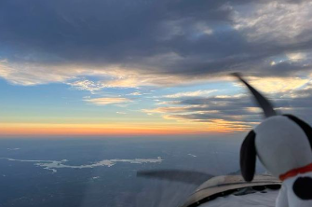

Snoopy flies east, courtesy of Doc Herrington
MERRY CHRISTMAS SNAG !!

SNAG NEWSLETTER/DECEMBER 2022
Lee Holmes
11881 Longfellow Cir
Shreveport, LA. 71106

